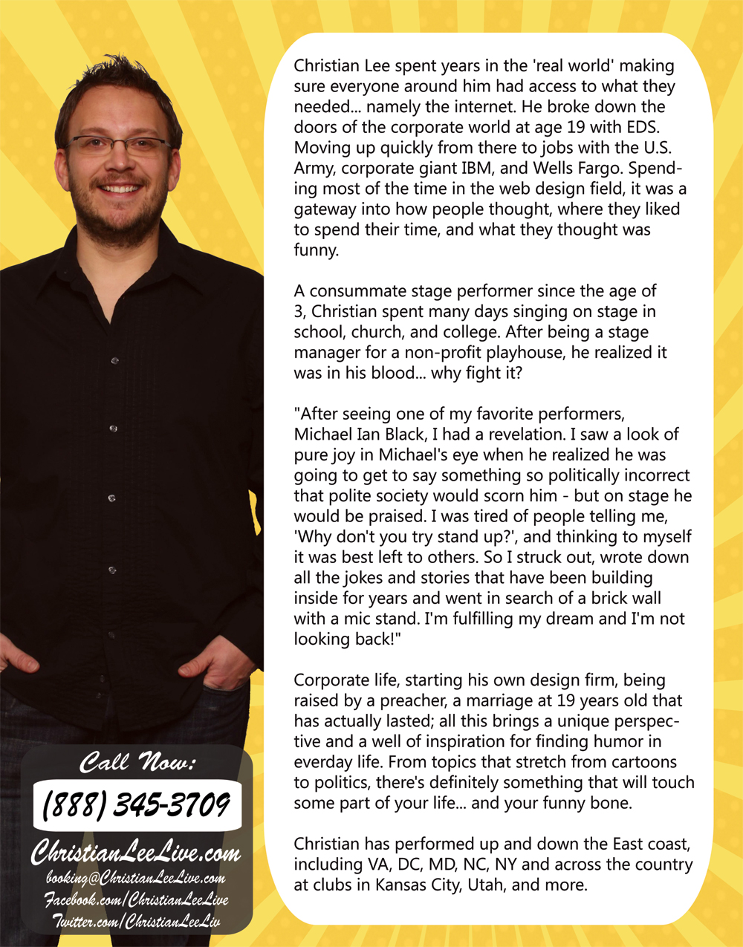

Christian Lee was born when his father was finishing Seminary in Atlanta, GA. Having a preacher for a father wasn’t always easy, and trying to follow in his footsteps proved quite tricky. Leaving Bible college unsure of his path, Christian spent years in the 'real world' making sure everyone around him had access to what they needed... namely the internet. He broke down the doors of corporate America at age 19 with EDS, moving up quickly with firms like IBM, even the U.S. Army. Spending most of the time in the web design field, it was a gateway into how people thought, where they liked to spend their time, and what they thought was funny.

A consummate stage performer since the age of 3, Christian spent many days singing on stage in school, church, and college. After being a stage manager for a non-profit playhouse, he realized it was in his blood... why fight it?

"I had what could only be called a revelation. What I felt needed to be heard from the stage, especially at churches, wasn’t being said. I started writing down all the jokes and stories that had been building inside. Then, I went in search of a mic stand and a crowd. After years of toil, comes the fruit of your labor. I'm fulfilling my dream and I'm not looking back!"

Raised by a preacher, Bible college, corporate life, starting his own design firm, a marriage at 19 years old that has actually lasted; all this brings a unique perspective and a well of inspiration for finding humor in everyday life. Topics stretching from cartoons to salvation, there's definitely something that will touch some part of your life... and your funny bone.

Christian performs across the country. He just returned from a stint in CA where he taped a show at the world famous Ice House Comedy Club. You may have seen him on Comedy Time or MAV TV.

Christian was recently invited to perform at The Great American Comedy Festival, Port City’s Top Comic, and The Plymouth Rock Comedy Festival.

“Christian has a veteran’s stage presence.” – Hatton Jordan/Comedian
“He’s ahead of the game and going in the right direction.” – David Beck/Comedian
“He inspired me to be Genuine in Christ. I truly felt God's hand was on him.” – Dr. Lewis Brown/Minister
“I laughed non-stop. Made me think about how I come across to the world.” – Audience
“It hit me in the middle of the show, that I was Supposed to be here. Thank You!” – Audience
“I loved the honesty.” “Very inspiring.” – Audience

(888) 345-3709 booking@ChristianLeeLive.com facebook.com/christianleelive twitter.com/christianleeliv

